**Belly Button Biodiversity Utilizing Plotly**

**Overview**

Using bacterial data collected from volunteers, the objective is to complete a dashboard panel with demographic information. Specifically, the volunteers can identify the top 10 bacterial species in their belly buttons.

**Graphs created with Plotly**

Horizontal Bar graph

[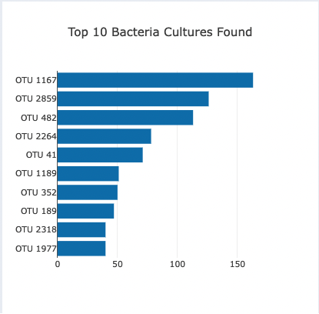](https://user-images.githubusercontent.com/104115586/182230279-7bc63740-473b-4df8-a151-ad7b8f6d48db.png)

Bubble plot

[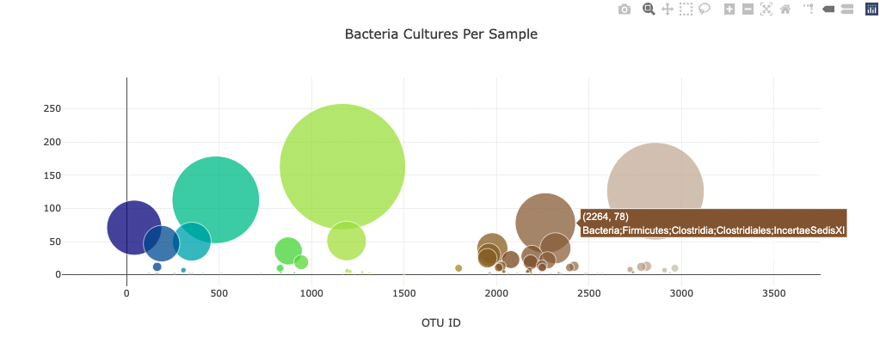](https://user-images.githubusercontent.com/104115586/182230349-016fa3bd-ac7d-40ff-ac4a-1b97b07af3d6.png)

Gauge chart

[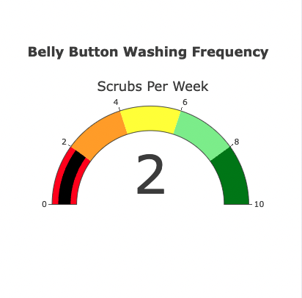](https://user-images.githubusercontent.com/104115586/182230369-e492cf7b-c589-4756-ae39-0c6e22333e57.png)

[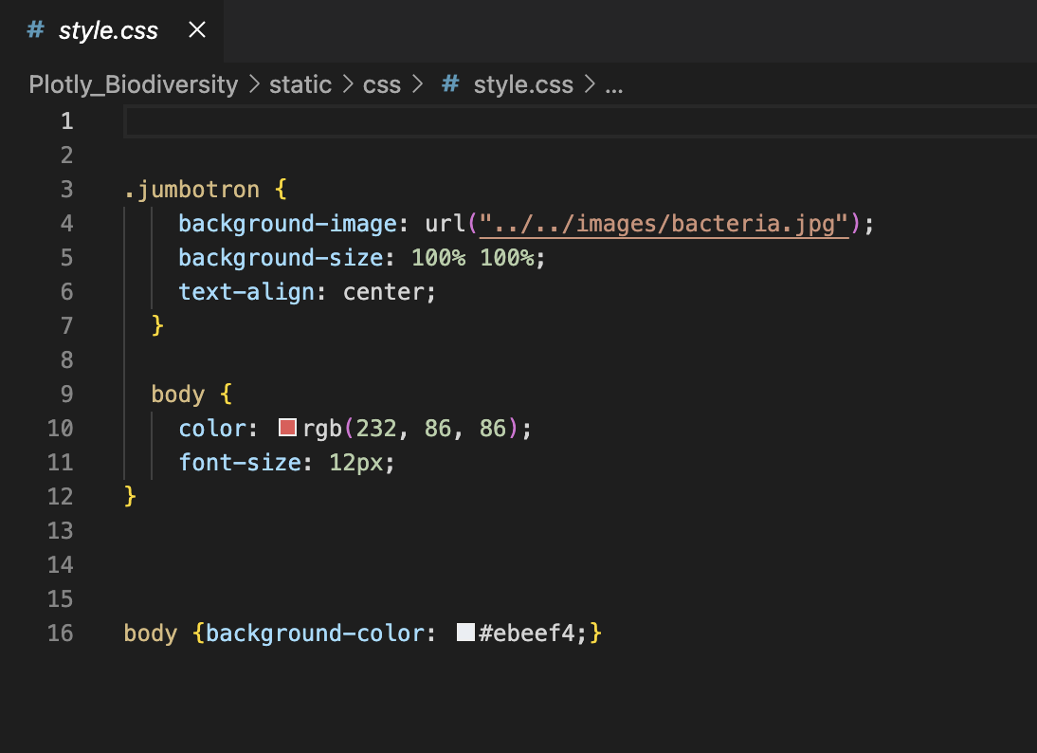](https://user-images.githubusercontent.com/104115586/182230546-72acea7f-da25-436b-87c9-86e448992b69.png)

**Full view**

[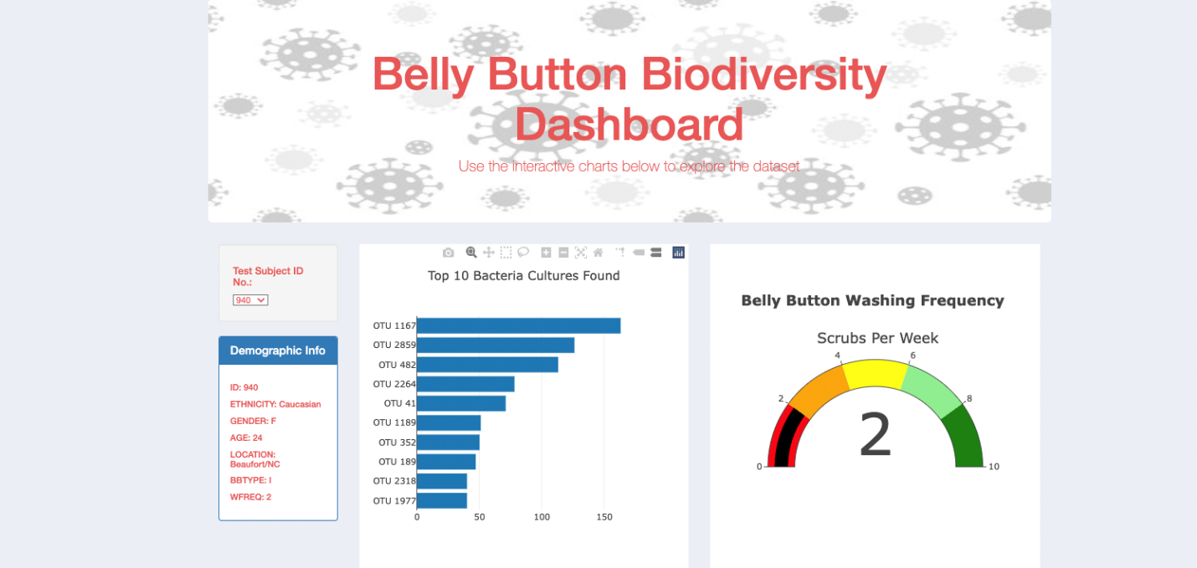](https://user-images.githubusercontent.com/104115586/182230779-6aed9452-bcd5-47f8-b019-8edb8f8ef0f7.png)